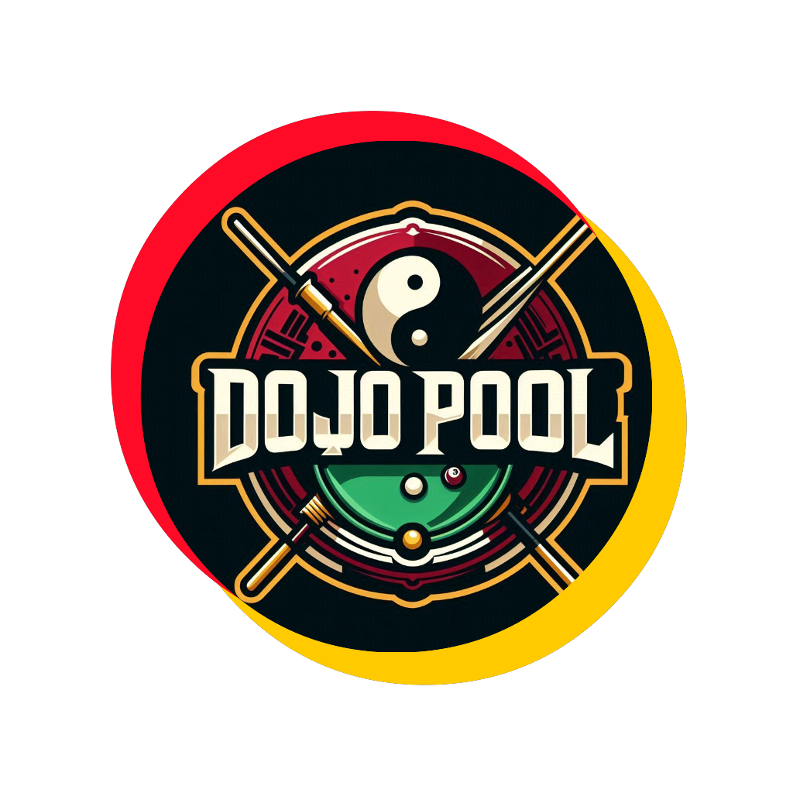

Dojo Pool: Business Plan (Hybrid Currency Model)

1. Executive Summary

Dojo Pool is an innovative social gaming platform that revolutionises traditional pool by integrating cutting-edge technology, competitive gameplay, and a unique kung fu anime aesthetic. Our hybrid currency model combines traditional fiat payments with an optional cryptocurrency (Dojo Coin), offering flexibility and innovation in the pub gaming experience.

Key Features:

- AI-powered gameplay monitoring and scoring

- Geographic expansion system with unlockable areas

- Narrative-driven progression with customizable avatars

- Kung fu anime-inspired visual style

- Integration of physical pool tables with a digital platform

- Hybrid payment system: Fiat currency and optional Dojo Coin

Initial Strategy:

- Launch website and mobile app

- Establish the first official Dojo for testing

- Implement fiat currency system initially

- Gradually introduce Dojo Coin in crypto-friendly jurisdictions

Financial Highlights:

- Initial Investment Required: $850,000

- Projected First Year Revenue: $500,000

- Projected Break-Even Point: 20 months

- Projected Franchise Growth: 200+ locations by Year 7

2. Product and Services

2.1 Dojo Pool Platform

- User account creation and management

- Real-time game tracking and scoring

- Leaderboards and achievements

- Social features for player interaction

2.2 AI Umpire System

- Overhead cameras for game monitoring

- AI algorithms for rule enforcement and scoring

2.3 Hybrid Payment System

- Fiat currency transactions for game entry and venue contributions

- Optional Dojo Coin for in-game purchases and special events

2.4 Dojo Coin Integration (Phase 2)

- Earn Dojo Coin through gameplay and achievements

- Use Dojo Coin for in-app purchases and tournament entries

- Exchange between fiat and Dojo Coin within the app

3. Market Analysis

Target Market:

- Primary: Adults aged 21-45 who enjoy social gaming and pub environments

- Secondary: Pubs, bars, and entertainment venues looking to increase customer engagement

Market Size and Growth:

- Global pub market value: $200 billion (2021), CAGR of 3.5%

- Mobile gaming market value: $98 billion (2020), CAGR of 12.3% (2021-2026)

- Cryptocurrency market: Rapidly growing, with increasing mainstream adoption

4. Marketing and Sales Strategy

4.1 Brand Positioning

- Position Dojo Pool as a cutting-edge, social pool gaming experience with flexible payment options

4.2 Marketing Channels

- Social media campaigns

- Influencer partnerships

- Targeted online advertising

- Participation in gaming, hospitality, and crypto industry events

4.3 Customer Acquisition and Retention

- Freemium model with basic free play and premium features

- Regular in-game events and tournaments

- Loyalty rewards program in both fiat and Dojo Coin

5. Operational Plan

Phase 1: Fiat Currency Launch (Months 1-6)

- Develop and launch the Dojo Pool website and app

- Implement fiat currency payment system

- Partner with initial venues for system installation

Phase 2: Dojo Coin Introduction (Months 7-12)

- Develop and test Dojo Coin system

- Launch Dojo Coin in crypto-friendly jurisdictions

- Educate users and venues on cryptocurrency benefits

Phase 3: Expansion and Feature Enhancement (Year 2)

- Expand to new geographic areas

- Implement the geographic expansion system

- Enhance AI umpire system and game features

Phase 4: Franchise Model (Year 3 onwards)

- Develop franchise model supporting both fiat and crypto options

- Begin offering franchises in key markets

- Expand nationally and internationally

6. Revenue Model

6.1 Fiat Currency Revenue

- Commission on game entry fees

- Licensing fees from participating venues

- Premium feature subscriptions

6.2 Dojo Coin Revenue

- Transaction fees on Dojo Coin exchanges

- Sales of Dojo Coin packages

- Revenue share from in-app purchases using Dojo Coin

7. Financial Projections

Year | Revenue | Expenses | Net Profit

1 | $500,000 | $700,000 | -$200,000

2 | $1,300,000 | $1,000,000 | $300,000

3 | $3,500,000 | $2,500,000 | $1,000,000

4 | $7,000,000 | $4,500,000 | $2,500,000

5 | $12,000,000 | $7,500,000 | $4,500,000

Projected Break-Even Point: 20 months

8. Funding Requirements

Seeking $850,000 in initial funding:

- $500,000 for platform development and initial venue setups

- $200,000 for marketing and user acquisition

- $150,000 for legal and regulatory compliance

9. Legal and Regulatory Considerations

- Partner with gaming law experts for compliance in fiat currency operations

- Engage cryptocurrency legal experts for Dojo Coin implementation

- Obtain necessary licences for both traditional gaming and cryptocurrency operations

- Implement robust KYC/AML procedures for both fiat and crypto transactions

- Ensure clear distinction from gambling activities where necessary

10. Risk Analysis and Mitigation

Risks:

- Regulatory challenges in gaming and cryptocurrency

- Technology implementation issues

- Market acceptance of the hybrid model

Mitigation Strategies:

- Maintain flexibility to operate primarily with fiat if needed

- Rigorous testing of all technology components

- Gradual rollout of cryptocurrency features with user education

11. Conclusion

The hybrid currency model of Dojo Pool offers a unique blend of traditional and innovative payment systems, positioning us to capture both conventional and crypto-enthusiast markets. By combining engaging gameplay with flexible financial options, Dojo Pool is poised to become a leader in the next generation of social gaming experiences.

This business plan adapts the original Dojo Pool concept to incorporate the hybrid payment model, balancing innovation with regulatory considerations and market readiness. Would you like me to elaborate on any specific section or aspect of this updated plan?